Heavy Rainfall in Thailand
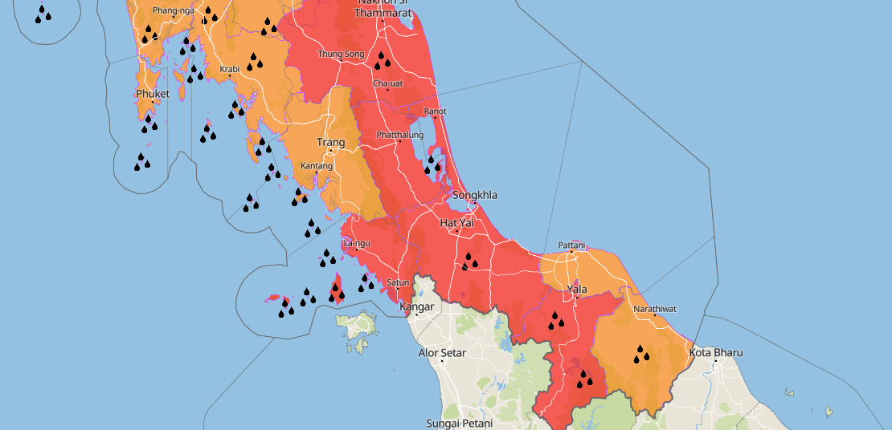
Source: meteoblue

Affected Areas
The regions (Southern Thai Provinces); Nakhon Si Thammarat, Songkhla, Hat Yai, Phatthalung, Trang (central–eastern parts), Satun (eastern parts), Pattani, Yala and Narathiwat will experience the strongest rainfall, highest flood potential, and most severe weather impacts.
Hazard Types
Heavy Rainfall/Floods
Hazard Summary
The moderate high-pressure system from China extend to cover the upper North, Northeast of Thailand and the South China Sea leading easterly winds brings moisture from the South China Sea and the Gulf to the upper country and the South with more rains and isolated heavy rains in the South. People in the upper country and the upper South should beware rain/thundershower and accumulated rain from today Dec 5th, 06:00 till 18:00 (6 hours from now).

