Hazardous Air Quality in Mali
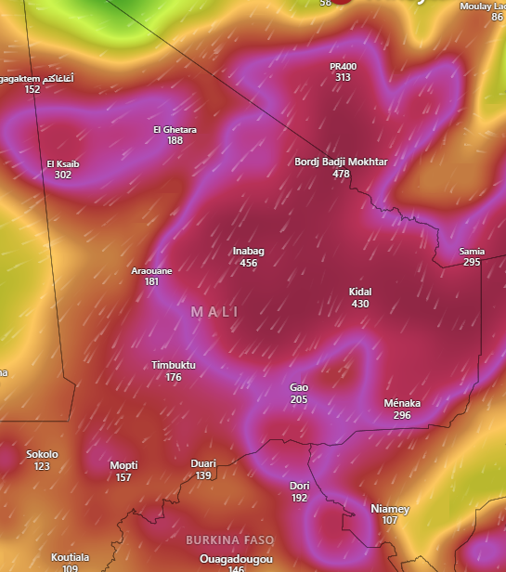
Affected Areas
Inabag, Kidal, Timbuktu, Gao, Menaka, El Ghetara, Araouane, El Ksaib, Horokoto, Yaguine, Tarkint
Hazard Types
Hazardous air quality
Hazard Summary
Mali is experiencing widespread severe air pollution, likely linked to Saharan dust storms, biomass burning, or wind-driven particulate matter. The central and northeastern regions show hazardous AQI levels, posing serious risks to respiratory and cardiovascular health. Southern areas have unhealthy but comparatively lower AQI values.

