Extreme Rainfall in Philippines
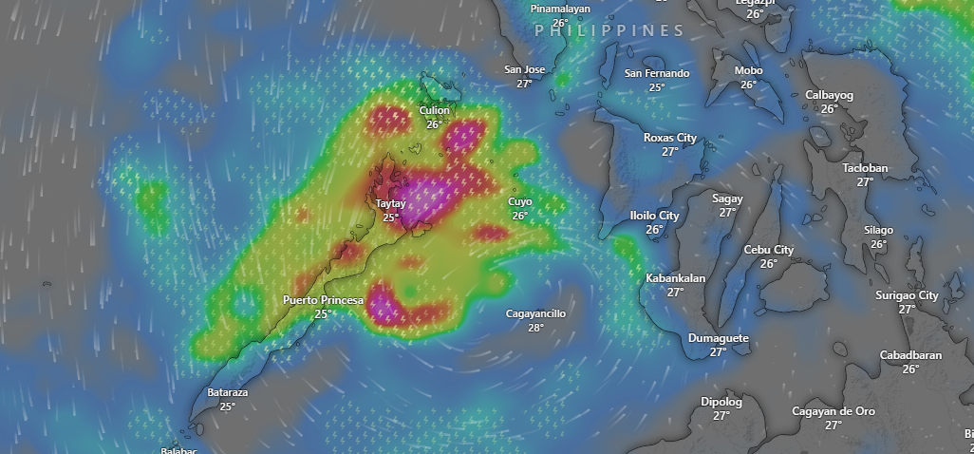
Source: windy

Affected Areas
The locations are in the core purple–dark red zone:Taytay (Palawan), Roxas (Palawan), El Nido / Northern Palawan coast, Culion, Linapacan and Northern Highlands of Palawan have the strongest hazard signature in the map (highest flood & landslide risk).
Hazard Types
Intense Rainfall/Flooding
Hazard Summary
The projection shows extreme convective rainfall concentrated over northern-central Palawan, indicating a high likelihood of flash flooding and landslides on 8th December, 2025. Surrounding areas, including Cuyo and central/southern Palawan, face heavy to moderate rainfall with localized flooding potential. Western Visayas (Iloilo, Negros, Dumaguete) may experience outer rainband precipitation, posing minor to moderate hydrological impacts.

