Extreme Rainfall in Philippines
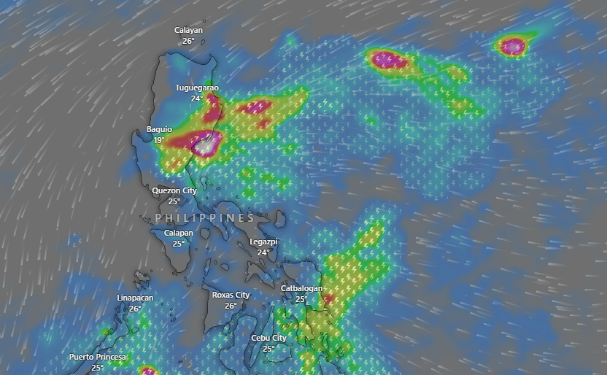
Source: windy

Affected Areas
The most affected areas include: Northern Luzon, especially Cagayan (Tuguegarao) and the Baguio–Benguet–Ilocos region, show the strongest convective cores and will receive the most intense rainfall. Moreover, parts of Eastern/Northern Samar and nearby areas in Eastern Visayas may also experience pockets of heavy rainfall.
Hazard Types
Extreme Rainfall/Floods
Hazard Summary
The most intense rainfall is expected over Cagayan, Baguio/Benguet, Ilocos, Cordillera belt, and parts of Eastern & Northern Samar, posing high risks of flash floods, landslides, and severe thunderstorms from Dec 7th till Dec 10th, 2025.

