Heavy Rainfall in Greece
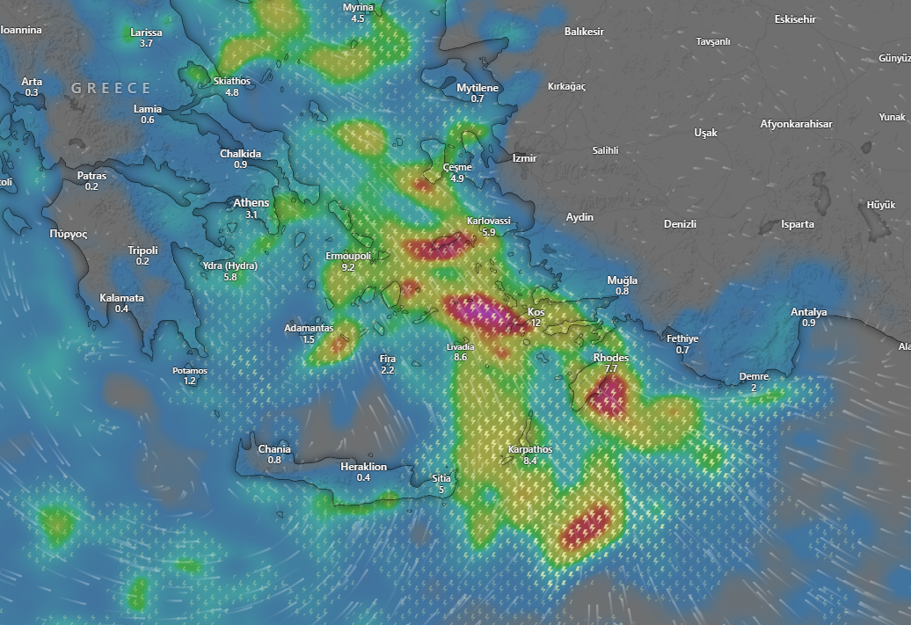
Affected Areas
Central Aegean Sea region, area around Kos, Southeast Aegean-Rhodes area, Karpathos region, Cyclades-Tinos / Andros-Syros area
Hazard Types
Extreme Rainfall/Flooding
Hazard Summary
A strong weather system is affecting the central and southeastern Aegean, bringing heavy rainfall and strong winds to several island regions. The most intense rain bands appear over Kos, Rhodes, Samos-Karlovassi, and the central Aegean between Ikaria, Chios, and Syros, where red and pink zones indicate the likelihood of very heavy downpours and thunderstorms. Surrounding areas including parts of the Cyclades, Crete, and the western Turkish coast are seeing moderate rain with gusty winds. This setup may lead to localized flooding, hazardous seas, and travel disruptions, especially in areas under the heaviest precipitation cores.

