**Heat Wave in the Eastern US**

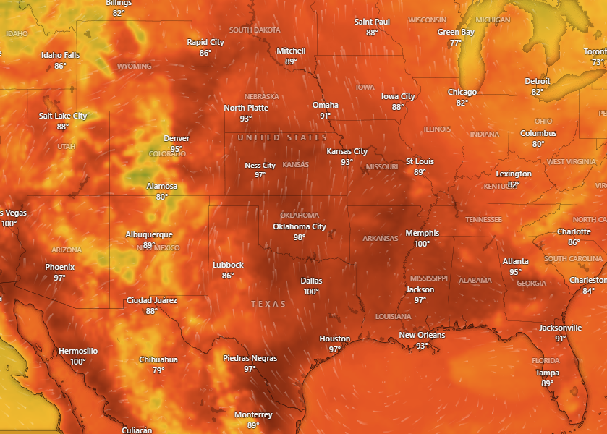

**Affected Areas**

Central and Southeast U.S.

**Duration**

July 21-24, 2025

**Hazard Types**

Heat Wave

**Hazard Summary**

Dangerous, long-lasting heat is expected across portions of the Central and Southeast U.S. A Heat Advisory is in effect from 1 PM to 7 PM Monday across Oklahoma and western north Texas with heat indices of 105 to 108 degrees. High temperatures will be around 95 to 105 degrees. Monday and next weekend may be the hottest days. Increased risk for heat related illness.