July 21, 2025

**Global Alerts – West Zone**

**Low pressure system – Central Tropical Atlantic**

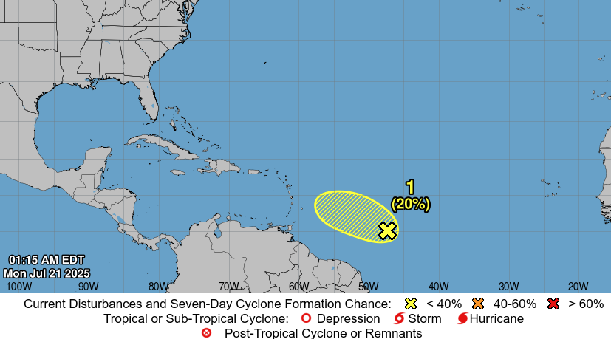

**Affected Areas**

For the North Atlantic...Caribbean Sea and the Gulf of America.

**Duration**

July 21 -July 28, 2025.

**Hazard Summary**

Showers and thunderstorms associated with a small area of low pressure located about 900 miles east-southeast of the Lesser Antilles have increased some during the past several hours. Environmental conditions are generally favorable for some additional development over the next day or so while the system moves west-north westward at 10 to 15 mph. By the middle of this week, environmental conditions are forecast to become unfavorable for further development.

* Formation chance through 48 hours...low...20 percent.

* Formation chance through 7 days...low...20 percent.