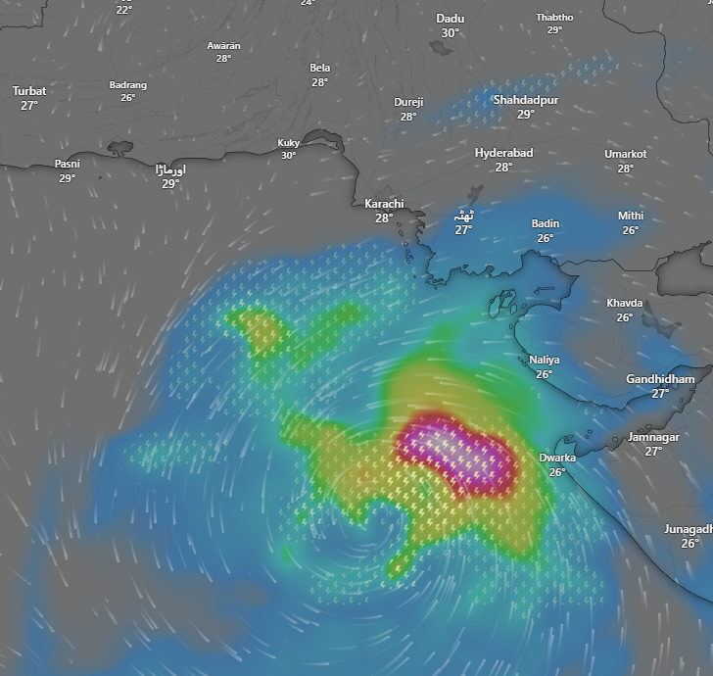 A well-defined low-pressure system over the north eastern Arabian Sea and the adjacent Saurashtra coast, India, has gradually shifted southwest over the past 12 hours. This system is anticipated to keep moving southwest towards the northwest Arabian Sea in the upcoming days. It has strengthened into a depression and is currently positioned, around 440 km south of Karachi. Due to its influence, light to moderate thunderstorms and rain are expected in the districts of Tando Muhammad Khan, Sujawal, Badin, Umerkot and Tharparkar, with some isolated activity likely in parts of Karachi Division. Sea conditions along the Sindh coast are expected to remain turbulent, with squally winds reaching 45–50 km/h. Fishermen are cautioned against going into deep waters until October 3.