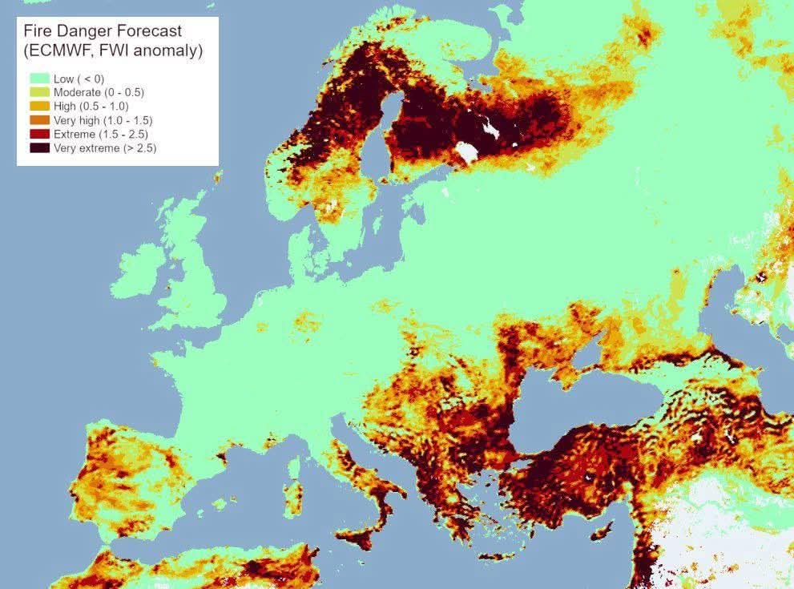

WILDFIRES 🔥 EUROPE

Europe is burning much faster in 2025:

237,153 ha already scorched — nearly double last year

1,250 wildfires in 2025

8.24 Mt CO₂ emitted — a major climate feedback