July 14, 2025

**Global Alerts – West Zone**

**Low pressure system – Atlantic coast of Northern Florida**

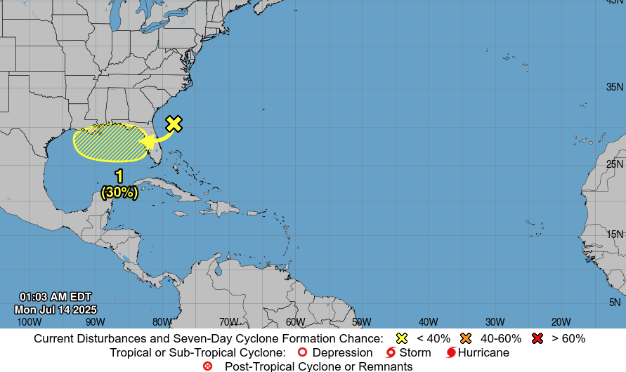

**Affected Areas**

Northern Florida

**Duration**

July 14 -July 20, 2025

Formation chance through 7 days...low...30 percent.

**Hazard Summary**

A trough of low pressure located offshore the Atlantic coast of northern Florida is producing disorganized showers and thunderstorms across portions of Florida, the north western Bahamas and adjacent Atlantic waters. This system is forecast to move westward across Florida during the next day or so, and into the north eastern Gulf by late Tuesday. Environmental conditions appear favorable enough to support some gradual development of this system while it moves westward to west north westward across the north eastern and north-central portions of the Gulf during the middle to latter part of this week. Regardless of development, heavy rainfall could produce localized flash flooding over portions of Florida and the north-central Gulf coast through the middle to latter portion of this week.