May 06, 2026
Strong Wind Gusts in Iran

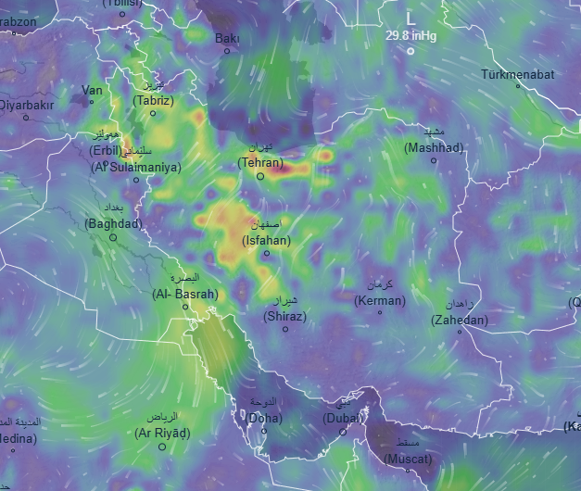
2026-5-6 11:00 2026-5-6 17:00
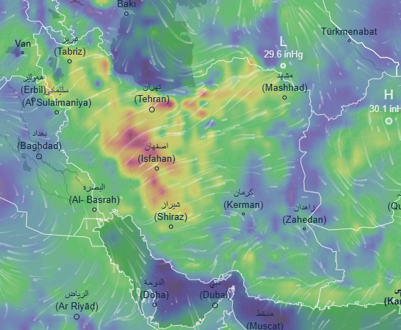

Affected areas: Tehran, Isfahan, Shiraz, Kerman, Mashhad, Al Basrah, Erbil
Description
Strong wind gusts are expected to intensify across Iran over the next few hours as a developing low-pressure system strengthens over the region. Winds are likely to reach speeds of 50–60 mph, increasing the risk of dust storms, reduced visibility, and potential damage in exposed areas.
Conditions may deteriorate rapidly, with gusty winds spreading across central and southern parts of the country. Residents are advised to take precautions, secure loose objects, and avoid unnecessary travel while staying updated with official weather advisories.

