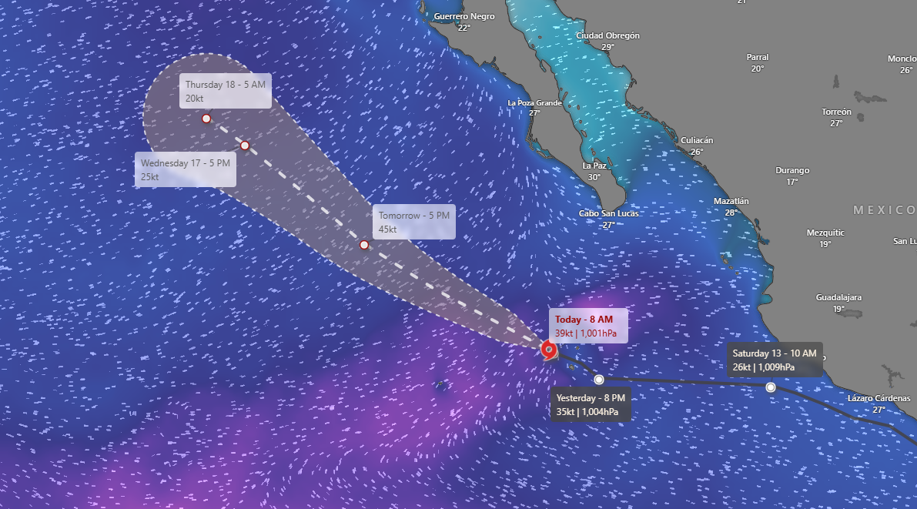

Mario, a [storm](https://www.thv11.com/weather)system swirling off Mexico's Pacific coast, has again become a tropical storm. There are no coastal watches or warnings in effect even though the storm was strengthening Sunday. Mario first gained tropical storm strength on Friday before weakening into a tropical depression just hours later. On Sunday morning, it again gained tropical storm status. Hours later, it was centered about 20 miles (35 kilometers) east-northeast of Socorro Island and about 280 miles (450 kilometers) south of the southern tip of Mexico's Baja California peninsula.

Maximum sustained winds were clocked at 45 mph (75 kph) and moving west-northwest at 7 mph (11 kph). The storm is expected to continue strengthening through Monday and then begin to weaken Monday night and Tuesday.